Dear Family,
A gentle reminder to bring your fully completed Drop-Off Form to your appointment, or feel free to fill it out digitally and email it back to us. The check-in time is 7:00am-7:30am (Or as stated by your doctor). Please allow about 30 minutes for check-in.
If you need to cancel this appointment, please email us back or call us directly.
If you have already sent us your form, please disregard this message.
If you are ill, please reschedule your appointment.
Sincerely,
Timonium Animal Hospital
2411 York Road
410 252 8820
***THIS DROP OFF IS ONLY AVAILABLE TO ESTABLISHED PATIENTS.

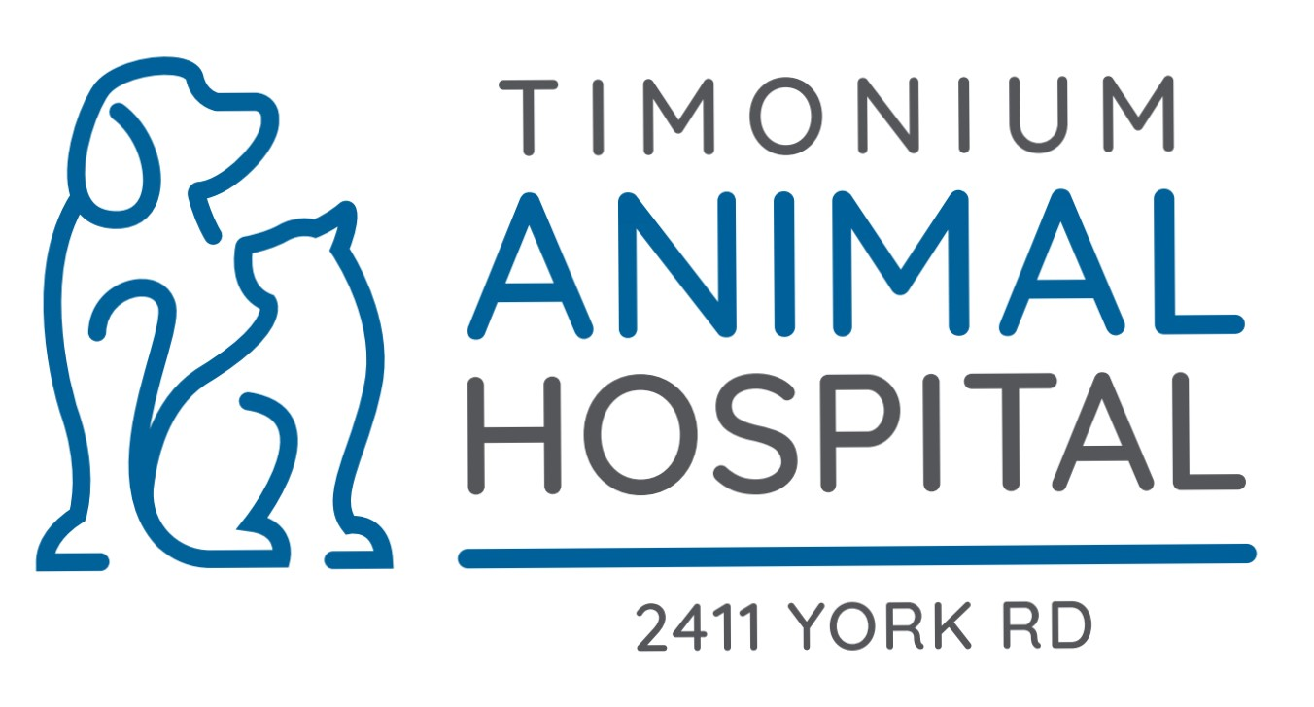
Treatment Check In Form
Owner’s Name: ___________________ Pet’s Name: _______________________

Today’s Date: ____________________ Time dropped off: __________________

Please understand that we must give priority to our emergencies and scheduled appointments first, then drop-off exams will be fit in between the doctor’s appointment schedule.
Day Boarding or Hospitalization charge will be applied at the time of check out.
What are the 2 best numbers that the doctor can reach you today?
1st Best Number: _________________________________ (circle one: home/cell/work)
2nd Best Number: _________________________________ (circle one: home/cell/work)
Email Address: ___________________________________

Upon examination, if the doctor feels it necessary, do you give permission to start:
1. Blood work panel:
Kidney/Liver/Glucose/Complete Blood Cell Count/Electrolyte Panel (195.00) _____
No, I do not give permission to do blood work at this time. _____
- X-rays/Radiographs (2 views 273.00 – each additional view 102.00/each):
Yes _____ No _____

Please list the presenting concern for your pet. Please be as specific as possible.

How long has the problem been going on? _________________________________________
Is your pet vomiting? (if yes, how often)____________________________________________
Is there any blood in the vomit? Yes _____ No _____
Is your pet sneezing? Yes _____ No _____ Any discharge from eyes or nose? _____
Any change in appetite? _____________________________________________________
Any change in activity level? __________________________________________________
Any increase in thirst and urination? ____________________________________________
If your pet has a lump or skin condition, please indicate the location on the diagrams below.
Pet’s Left Side Pet’s Right Side
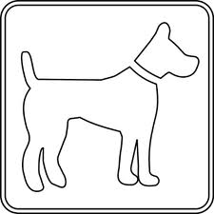

Signature of Owner or Caretaker: _________________________________date:___________

PLEASE CHECK YOUR VOICE MAIL MESSAGES BEFORE RETURNING DOCTOR’S PHONE CALLS. THIS HOSPITAL DOES NOT PROVIDE 24 HR CARE. (9/2025)
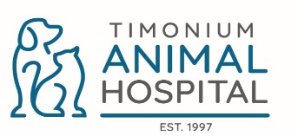
Owner Consent for CPR or DNR
** For surgical patients** If your pet requires sedation or general anesthesia to accomplish a procedure. Even though every precaution has been taken to assure a positive outcome, complications, including death, are possible. In the event that your pet has an anesthetic complication we need to have your wishes on file in order to guide us in case we are unable to reach you in a timely manner.
In addition to pre-surgical exams and laboratory analysis. Timonium Animal Hospital utilizes state of the art Monitoring equipment: EKG, Blood pressure, pulse oximetry and temperature monitoring, to aid our staff in effectively managing our sedated and anesthetized patients have dedicated personnel to assist them through recovery
** For hospitalized patients ** If your pet requires hospitalization for treatment and monitoring of serious medical problem. Every effort is being made to diagnose, treat, and care for your pet. In spite of our team’s best efforts, some medical conditions may cause your pet to deteriorate, and in extreme events, lead to cardiopulmonary arrest (loss of an effective heartbeat and ability to breath spontaneously.) in the event that your pet has a medical complication or cardiopulmonary arrest, we need to have your wishes on file in order to guide us in case we are unable to reach you in a timely manner.
CPR- Cardio Pulmonary Resuscitation is the treatment provided for a pet who has stopped breathing or whose heart has stopped beating. Resuscitation of a pet who has stopped breathing (but still has a heartbeat) is more likely to be successful than a pet who has no heartbeat.
DNR- Do Not Resuscitate means that if a pet stops breathing or his/her heart has stopped, no effort should be made by our veterinary professionals to attempt to revive the pet, and the pet will be allowed to die.
IN THE EVENT OF A MEDICAL CRISIS
I wish for the doctors of the Timonium Animal Hospital to perform CPR on my pet if he/she suffers respiratory or cardiac arrest. I understand that my pet may or may not respond to this life-saving procedure. I understand that if my pet survives because of CPR, he/she may have permanent health issues. CPR cost can start at $600.00.
Owner Print Name: ___________________________ Pet Name: ________________
Signature____________________________________ Date _____________
I DO NOT want CPR performed on my pet. I understand that if my pet stops breathing, and/or his/her heart stops beating, that my pet will die. I elect to have DNR orders placed on my pet’s record for his/her sedated procedure.
Owner Print Name: ______________________________Pet Name: _________________
Signature_______________________________________ Date _____________

